My Account
My Account support guide.
Version 1.0

Contents
1 Which payment options are available? 2
2 How will I be billed? 2
3 Claranet SOHO contact and payment details 2
4 Which online portal will I use? 2
5 How do I view invoices in customer.clara.net? 3
6 How do I view invoices in admin.clarahost? 4
7 How do I update my address details? 5
8 How do I amend my billing information? 5
9 How do I add card details to admin.clarahost? 6
10 How to create a new mailbox (Web hosting)
11 How to make changes to a mailbox (Web hosting)
12 How to access you webspace (Web hosting)
13 How to access your DNS Zone (Web hosting)

Setup
- Which payment options are available?
Claranet SOHO supports payments made via direct debit, credit or debit card, cheque and BACS transfer.
There are some circumstances where you’re preferred payment method can’t be supported. Please call our Accounts Department to discuss this in more detail.

- How will I be billed?
For accounts that are billed monthly, payments will be taken on the same day each month via the payment method you’ve selected.
Accounts which are billed annually will receive an email one month before the renewal date. These reminders will be emailed to the contact email address provided so it’s important to check you’re contact details are up to date.

- Claranet SOHO contact and payment details
If you pay for your services via BACS tranfer, our details are below:
Claranet Ltd
Account number - 20529112
Sort code - 50-00-00
Our Accounts Department is available Monday to Friday between 9am and 5:30pm.
Telephone: 0800 640 8009
Email: accounts@clara.net
Please note, we will need to go through some security checks before discussing your account via both email and phone to protect your account against fraudulent activity.

Troubleshooting
- Which online portal will I use?
FreeUK accounts need to access: https://admin.freeuk.com/login.
Any domains hosted with Claranet SOHO will use: https://admin.clarahost.co.uk/login.
All other accounts can be managed here: https://customer.clara.net.
If you're unsure which customer portal you should be using, please contact our accounts team on 0800 640 8010 and press option 5 or email accounts@clara.net.
- How do I view invoices in customer.clara.net?
Invoices can be viewed via your online portal. Please note, this only applies to @clara.co.uk and @dircon.co.uk accounts.
Log into the control panel here.
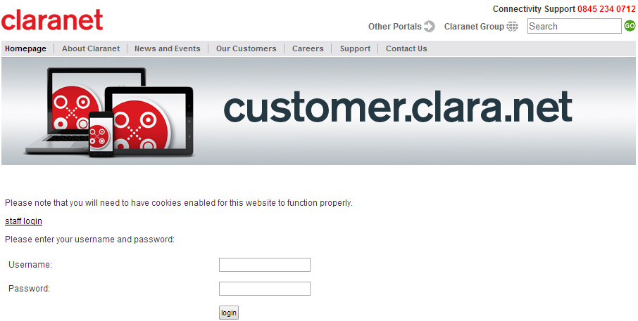
You can view invoices by selecting VAT invoices. Your invoices will be listed in the below screen for you to view/print.
We've used a test account so there are no invoices to show.
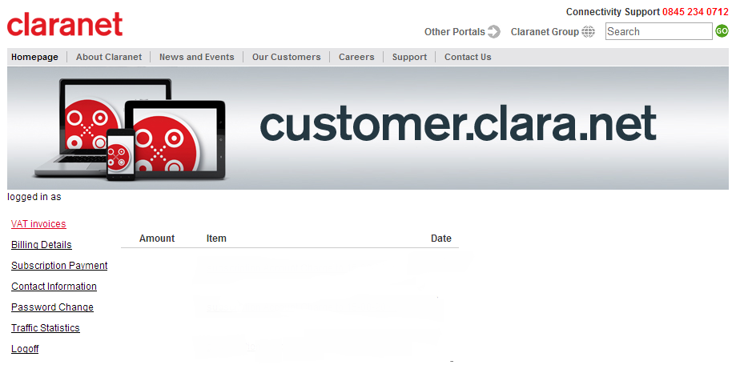
- How do I view invoices in admin.clarahost.co.uk?
Log into the control panel here.
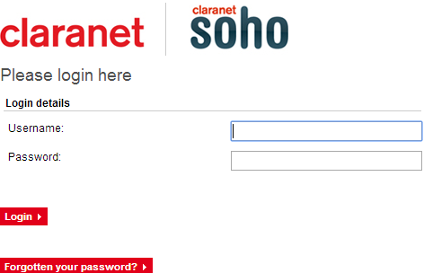
When this page is displayed, select View Invoices.
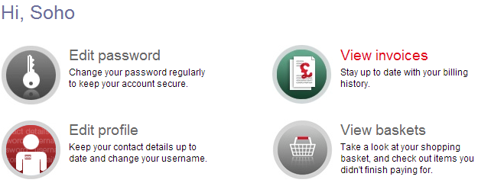
All invoices are listed and can be viewed individually.
- How do I update my address details?
Please note, if you have a FreeUK account you can’t update address or contact details online and will need to contact our Support Department. (08006408010)
Any other accounts will accept changes to address and contact details online via the control panel.
Clara Email Address (@clara.co.uk): Log into the control panel, select Contact Information and tick the fields you wish to update then make any necessary changes.
Web Hosting: Log into the control panel and select Edit Profile. You can then update all of the contact information on this screen.
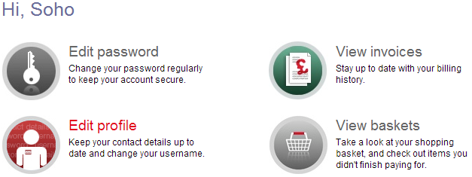
- How do I amend my billing information?
You can amend your billing information and contact details by selecting the fields which you need to update with the tick box and making the necessary changes.
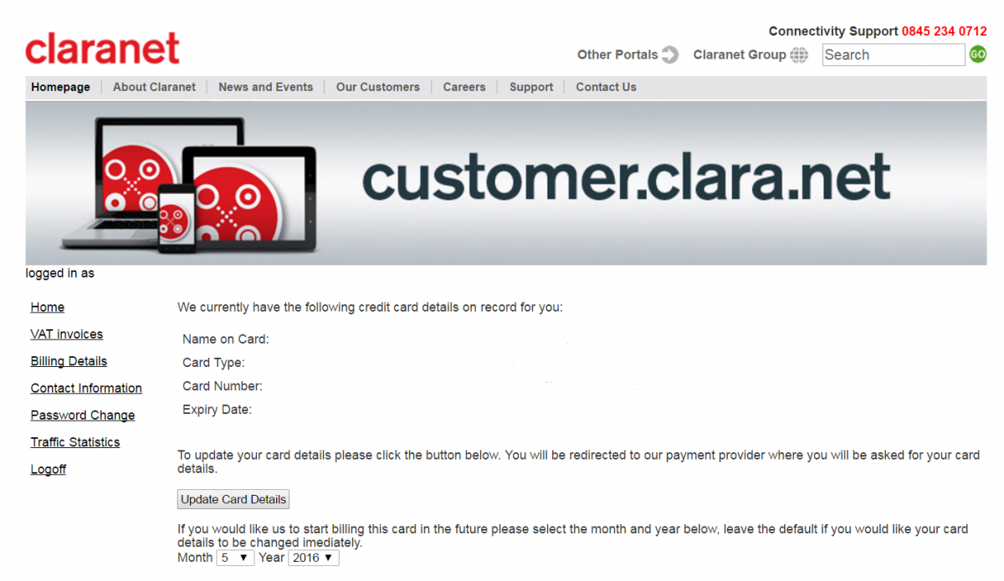
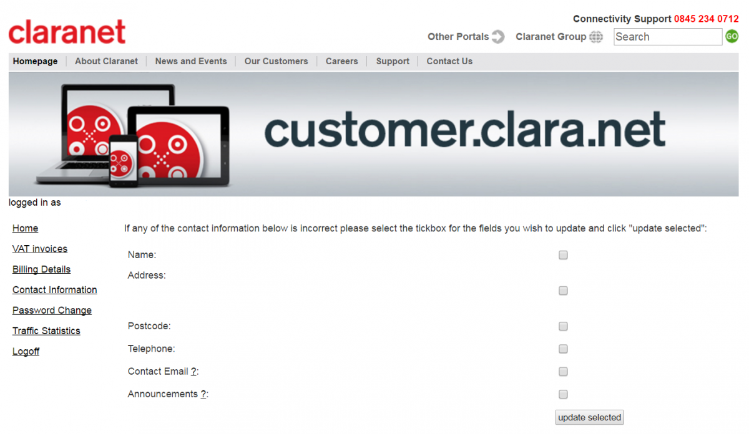
- How do I add card details to admin.clarahost.co.uk?
Log into the control panel here.

Select Edit Credit Cards.

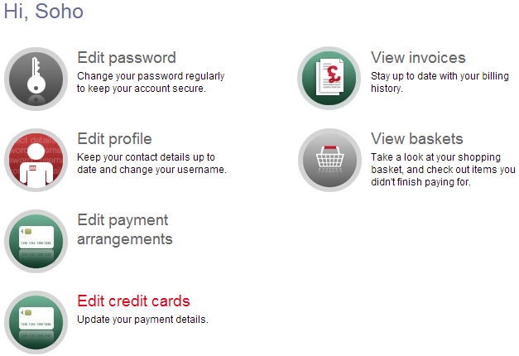
Select Register New Card which will take you to the payment screen where you can add the card details.
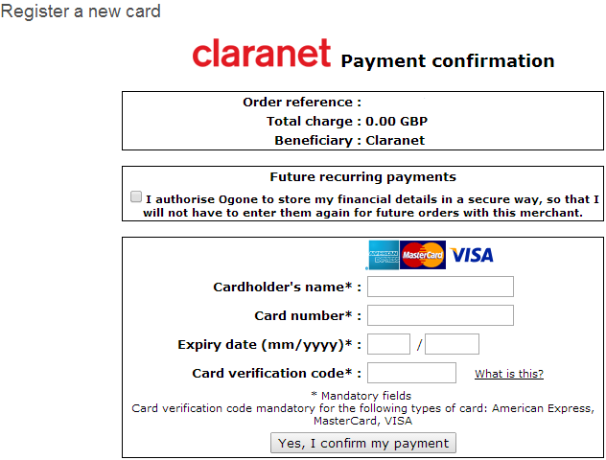
After this, go back to the home screen and select Edit Payment Arrangements. If you are struggling to update your card or are receiving “Access Denied” please contact our support line (08006408010).
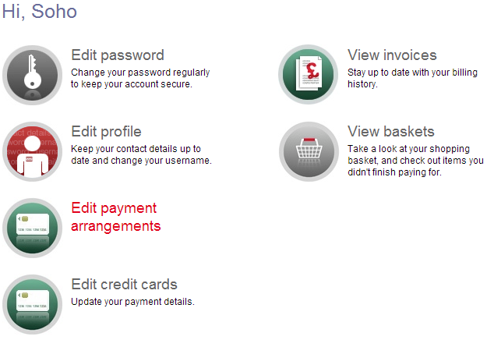
The new card will then be updated. Select the new card added as the primary card and update. If you do not complete this, our system will continue to attempt to take payment from the old card. Once a new card has been registered the old card will be removed.
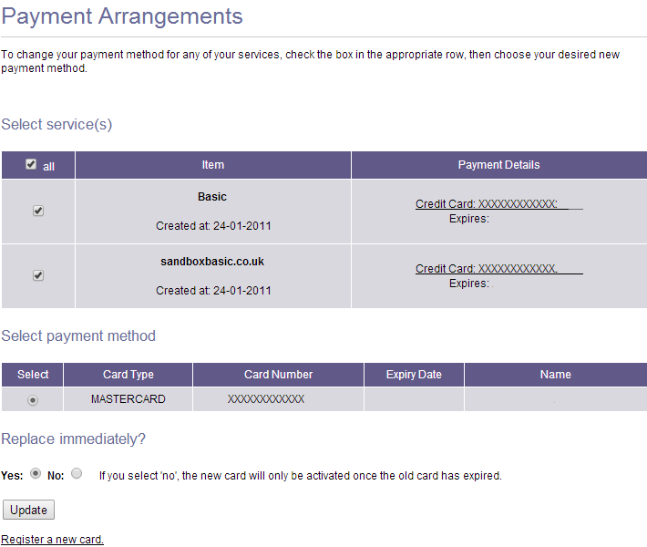

- . How to create a new mailbox (Web hosting)
Log into the control panel here.

Click on the domain name you want to make the changes to, under ‘Hosting’
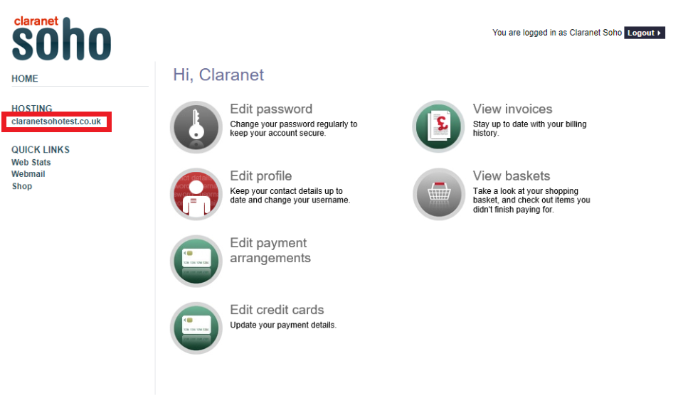
Select the email tab along the top
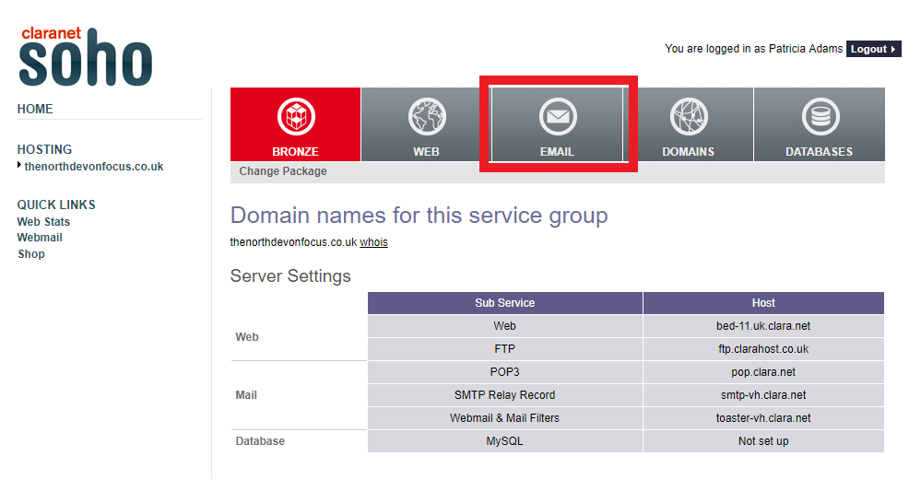

• In the Email Configuration box, you can create a mailbox. You will need to put in a new username and password in the designated areas. Press Submit when done to create it.

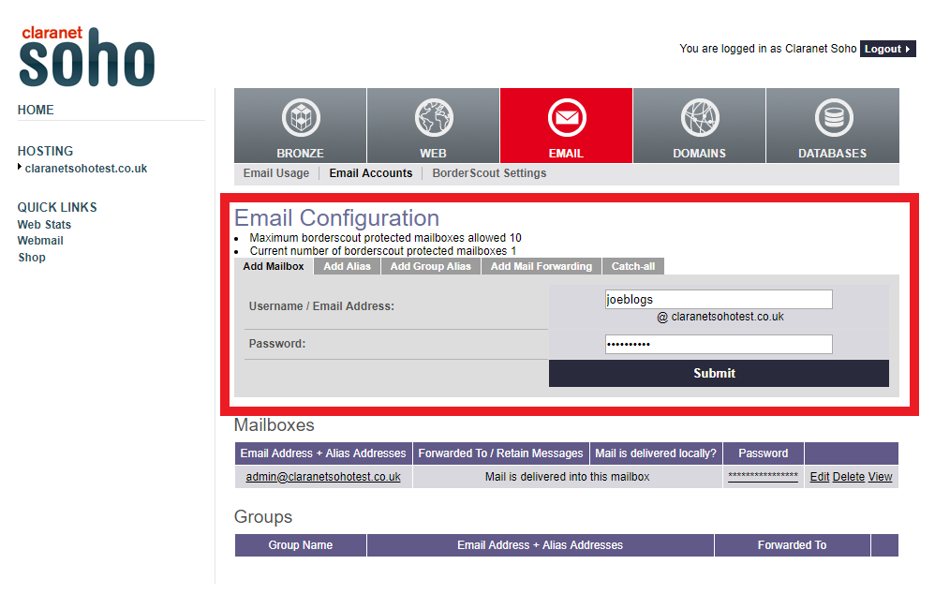

• Allow the mailbox up to 15 minutes to be fully set up and working. Once you’ve added it you should see it under the Mailboxes area. You can press the asterisks to reveal the password.
• After 15 minutes has passed you should be able to log into the mailbox, either by going to https://webmail.clara.net/ or setting it up on your email client (i.e. Outlook, Apple Mail). Please visit our Support page to for assistance on setting it up on an email client at https://www.claranetsoho.co.uk/support/email

- . How to make changes to a mailbox (Web hosting)
Log into the control panel here.
(Please follow the steps in section 10 on how to reach the email area)

- Change Password
To edit the password, click ‘Edit’ on the relevant mailbox. If you wish to change the password, after pressing ‘Edit’, you can type in a new password, press Submit when done. If the password isn’t strong enough you will be given an error message, i.e. “Password is based on a dictionary word”, which means it’s based on a word that is too simple. Please visit https://www.claranetsoho.co.uk/support/keep-secure/setup/password-security for password advise.
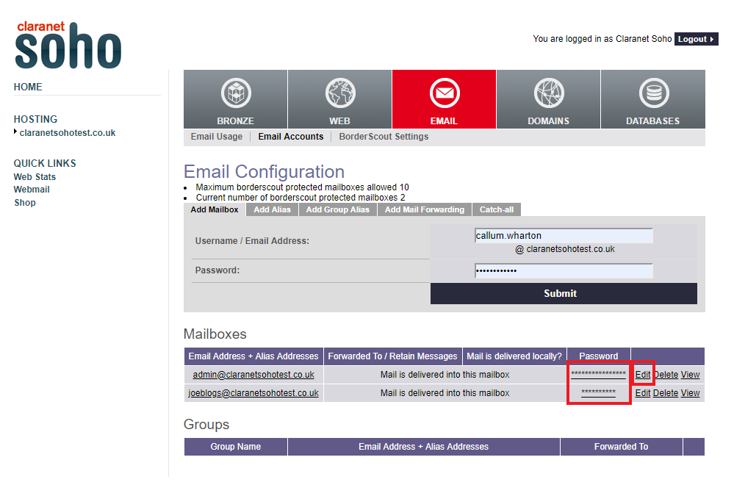

- Delete a Mailbox

To delete an email account, click the ‘Delete’ option. You will be asked if you are sure, press yes. Please be aware once a mailbox is deleted all emails save on the server (webmail) will be deleted along with it and won’t be able to be recovered.

- Adjust the size of a Mailbox

To view/change the size of a mailbox you’ll need to select ‘email Usage button’ along the top. Here you will see all the information regarding your mail quota. You can also see the overall mail space you have and have used. Simply change the number to a desired size and press ‘Update’ when you have finish changing any quota. Please note 2000mb is the maximum size a mailbox can be, and the message count cannot be adjusted.
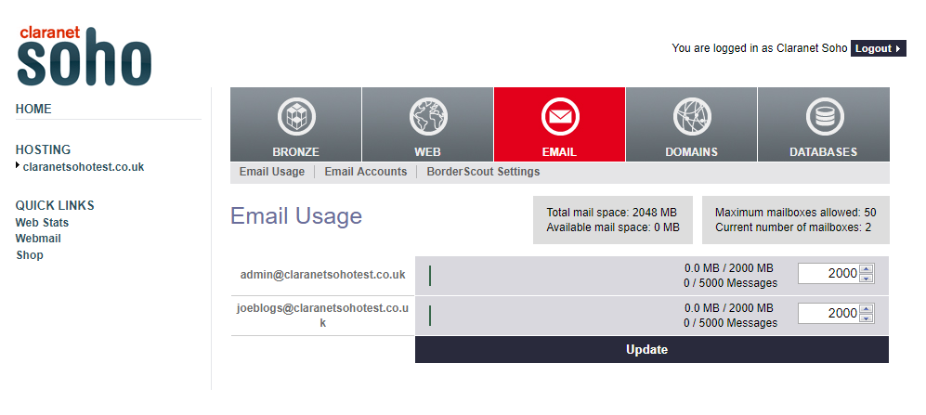

- Alias, Forwarding & Catch All

With in the email area they are several sub headers contain different email configuration options, ‘Add Alias ‘allows you to add an alias to a previously set up mailbox. ‘Add Mail Forwarding’ allows you to add forwarding to a designated email address and if to keep the forwarded email on the server. The ‘Catch All’ allows you to make already set up mailbox catch every email that arrives the domain.

- How to access your webspace (Web hosting)
Log into the control panel here.
Click on the domain name you want to make the changes to, under ‘Hosting’, Select the ‘Web’ tab along the top. Here you see all the information regarding your webspace, to access your webspace you’ll need to locate your FTP details, these details will allow you to log into your webspace via a FTP client, where you can upload your web-files.
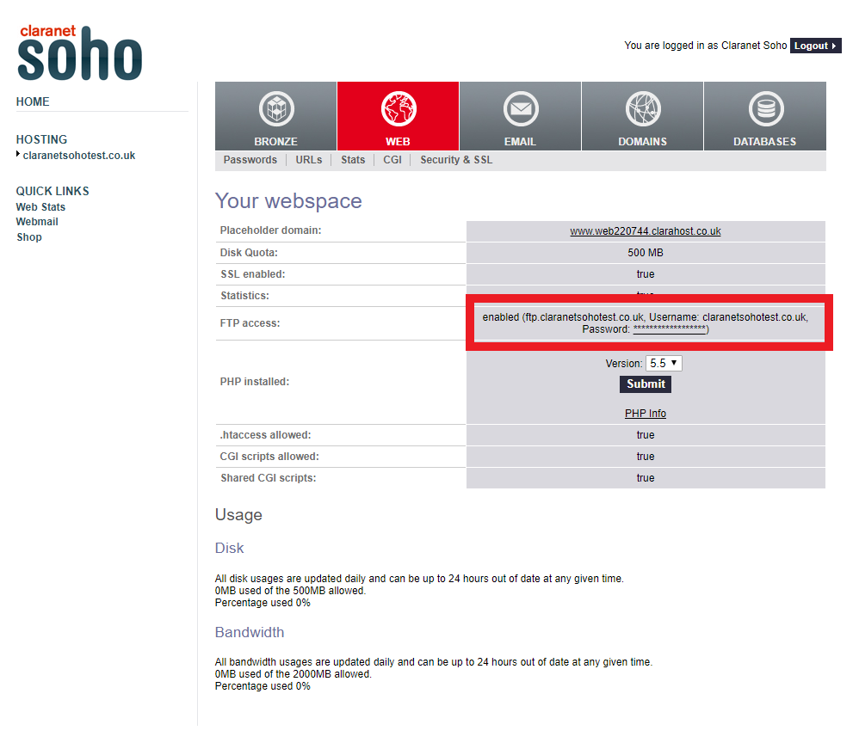

- How to access your DNS Zone (Web hosting)
Log into the control panel here.
Click on the domain name you want to make the changes to, under ‘Hosting’, Select the ‘Domain’ tab along the top. From you’ll be able to see and select from your various domains on the account, to make change to the DNS you need to select the ‘edit’ button and here you’ll be able to make any changes you need to.

